How to Install Fedora28 on Virtual Box Manager [Windows and Ubuntu]

- Download Fedora 28 from https://archives.fedoraproject.org/pub/archive/fedora/linux/releases/28/Workstation/x86_64/iso/
- Open Virtual Box Manager.
- Click on “New”.
- Enter name as Fedora28, and it automatically sets default Type and version.
- Click on “Next”.
- Select Memory Size as 8MB and Click on “Next”.
- Select “Create a virtual hard disk now”.
- Select VDI (VirtualBox Disk Image) and click on “Next”.
- Select Storage as “Dynamically allocated” and click on “Next”.
- Select size as 80GB and Click on create.
- On Virtual Box, Right Click on Fedora28 and select Settings.
- Click on “Advanced” and Select Bidirectional.
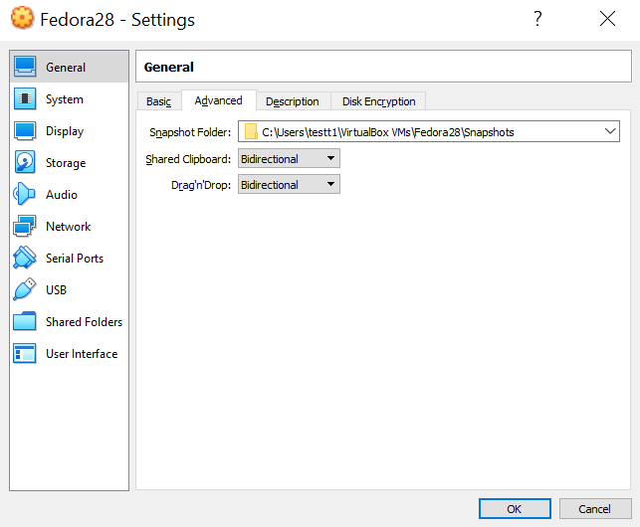

- Select Storage and click on Empty from Controller: IDE and click on Disk button, and select “choose Virtual Optical Disk File…”
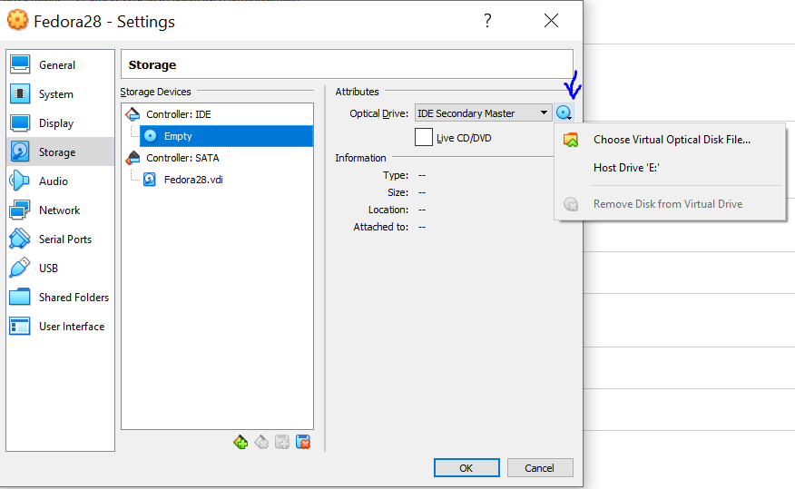

- Go to the Location where you stored the iso
- Click on Ok.
- Right Click Fedora28 Go to start Click on Normal Start.
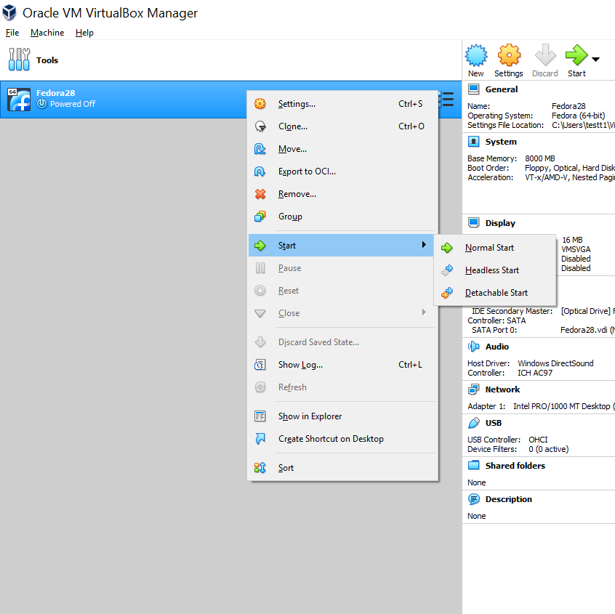

- Once the Virtual machine starts select “Start fedora”.
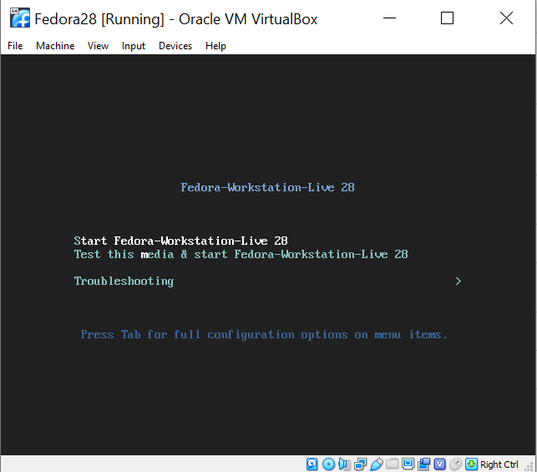

- Click on “Install to Hard Drive”.
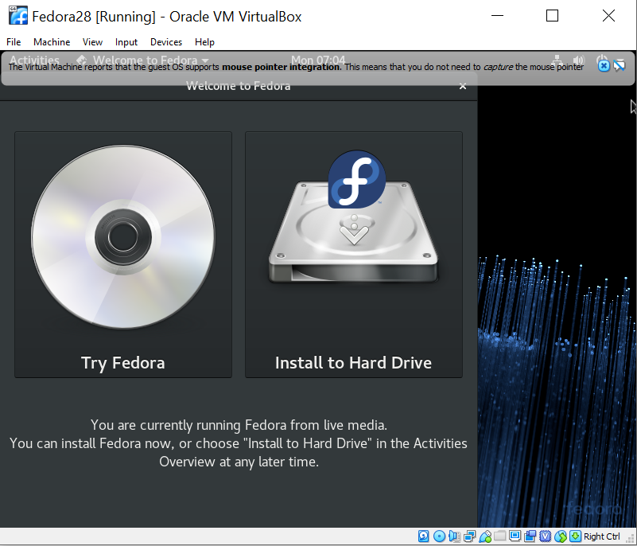

- Fedora28 Welcome Page appears and select your preferred language which is English by default, and Select “Continue”.
- Click on Installation Destination, keep the default settings and click “done”.
- Then Select “Begin Installation”.
- Once the Installation Completes, click on Quit.
- Power Off the Fedora28.
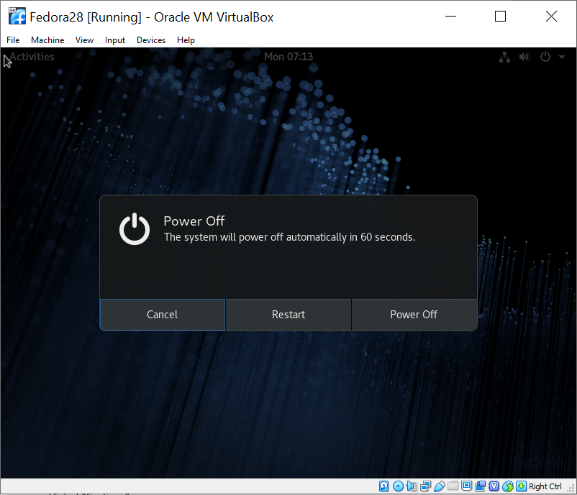

- On the Virtual Box, Right Click Fedora28 and open Settings, Select System and uncheck Floppy and Optical options. Check only the hard disk check box. Click Ok.
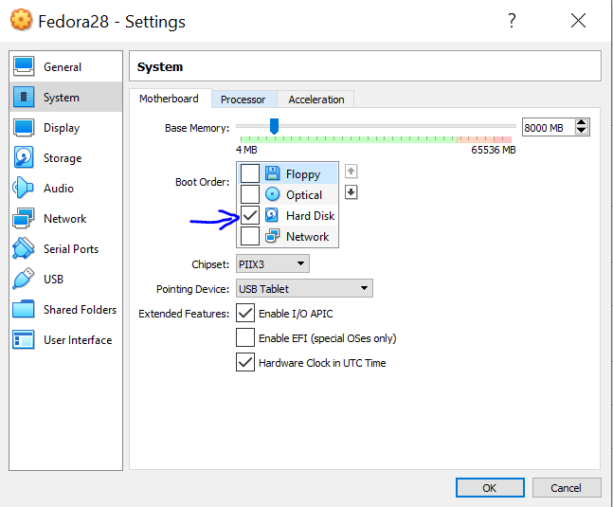

- Right Click Fedora28 and go to start and Click on Normal Start.
- Fedora28 loads from the Hard disk and Welcome Page appears.
- Click on Next Next Skip.
- Enter Full name as User1 and User name as user1 and Click Next.
- Enter Password as LINUXrocks! and Click Next.
- Click “Start Using Fedora”.
- Now, you should be able to Log in Fedora28 with Provided username and Password.

